­­



Submitted to

:

Mam Humaira Batool

***BS-Software Engineering 4th-E***

Title: LAB Exercise 1

DBMS

Hamza Mehmood

Roll# SP-21-110

NUML-S21-23530



National University of Modern Languages

DBMS (MySQL)

# Chapter # 1 Exercise

**Question # 02**

iSQL*Plus commands access the database(True/False).

**Answer**: **FALSE**

**Question #03**

The following SELECT statement executes successfully:

SELECT last_name, job_id, salary AS Sal

FROM employees;

**Answer: True**

**Question # 04**

The following SELECT statement executes successfully:

SELECT *

FROM job_grades;

**Answer: True**

**Question # 05**

There are four coding errors in this statement. Can you identify them?

SELECT employee_id, last_name

sal x 12 ANNUAL SALARY

FROM employees;

**Answer: SELECT employee_id, last_name, salary*12 As “ANNUAL SALARY” FROM employees;**

* The EMPLOYEES table does not contain a column called sal. The column is called SALARY.
* The multiplication operator is *, not x, as shown in line 2.
* The ANNUAL SALARY alias cannot include spaces. The alias should read

ANNUAL_SALARY or be enclosed in double quotation marks.

* A comma is missing after the column, LAST_NAME.

**Question # 06**

Show the structure of departments table. Select all data from the table.

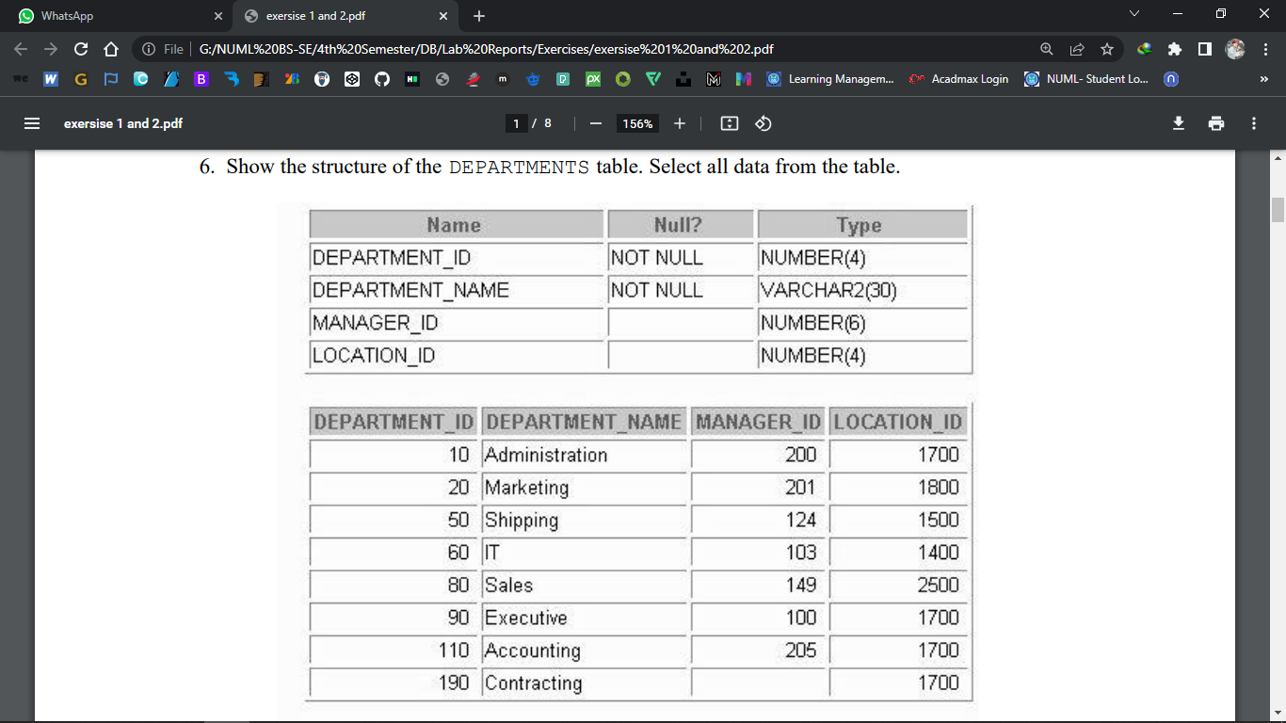

**Answer:**

* **Describe departments;**
* **SELECT * FROM departments;**

**Question #07**

Show the structure of Employees table. Create a query to display last name, job code, hire date and employee number for each employee, with employee number appearing first. Save your SQL statement to a file named labl_7.sql

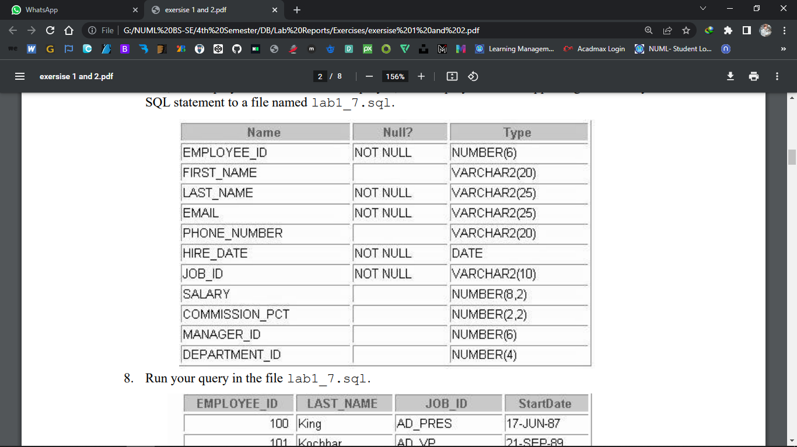

**Answer:**

* **DESCRIBE employees;**
* **SELECT employee_id, last_name, job_id, hire date FROM employees;**

**Question # 08**

Run your query in the file lab_7.sql.

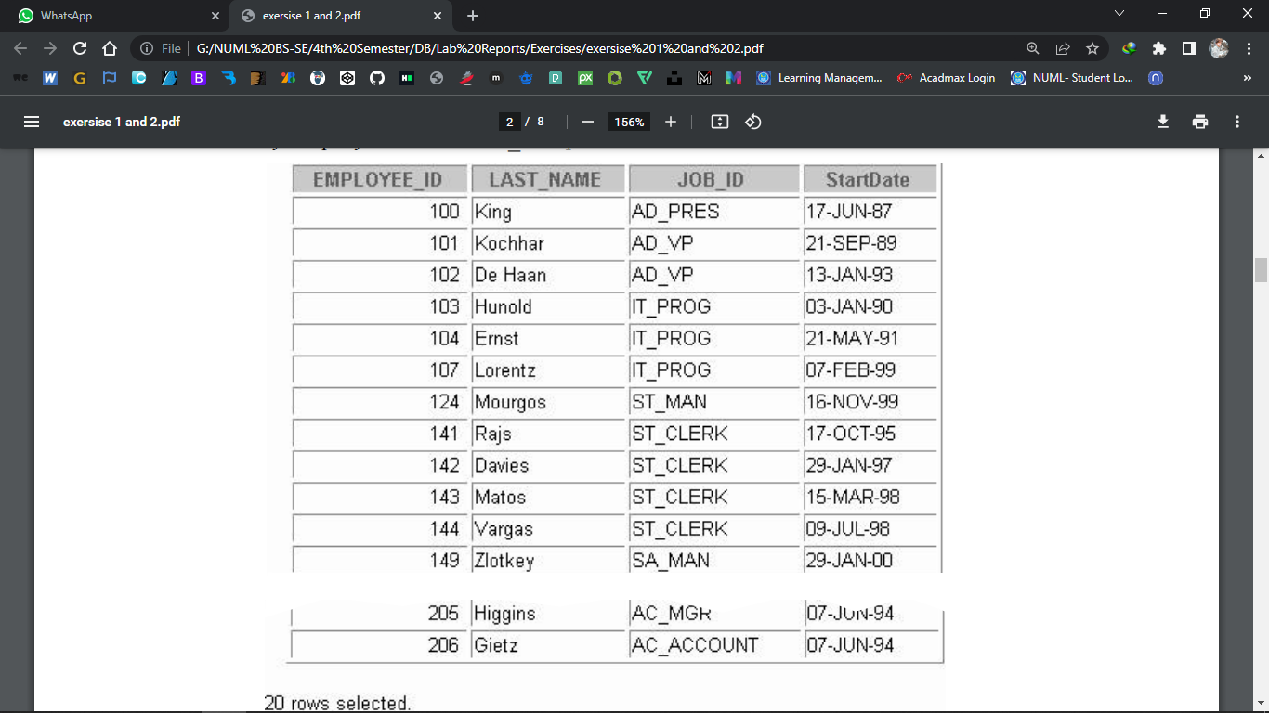

**Answer:**

**SELECT employee_id, last_name, job_id, hire_date FROM employees;**

**Question # 09**

Create a query to display unique job codes from the employees table.

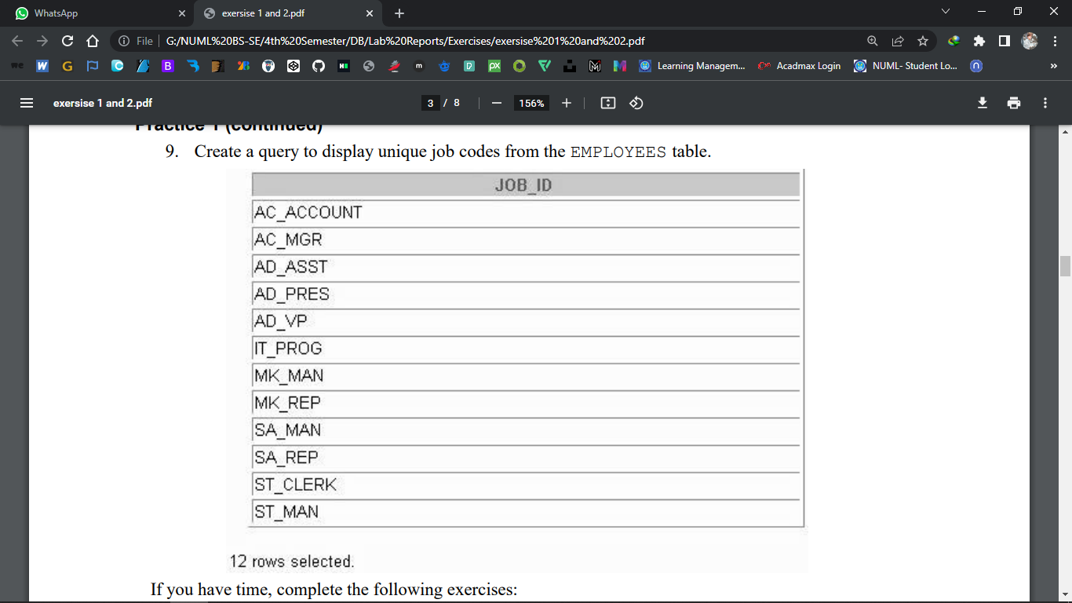

**Answer:**

**SELECT distinct job_id FROM employees;**

**Question # 10**

Copy the statement from lab1_7.sql into the iSQL*Plus Edit window. Name the column

headings Emp #, Employee, Job, and Hire Date, respectively. Run your query again.

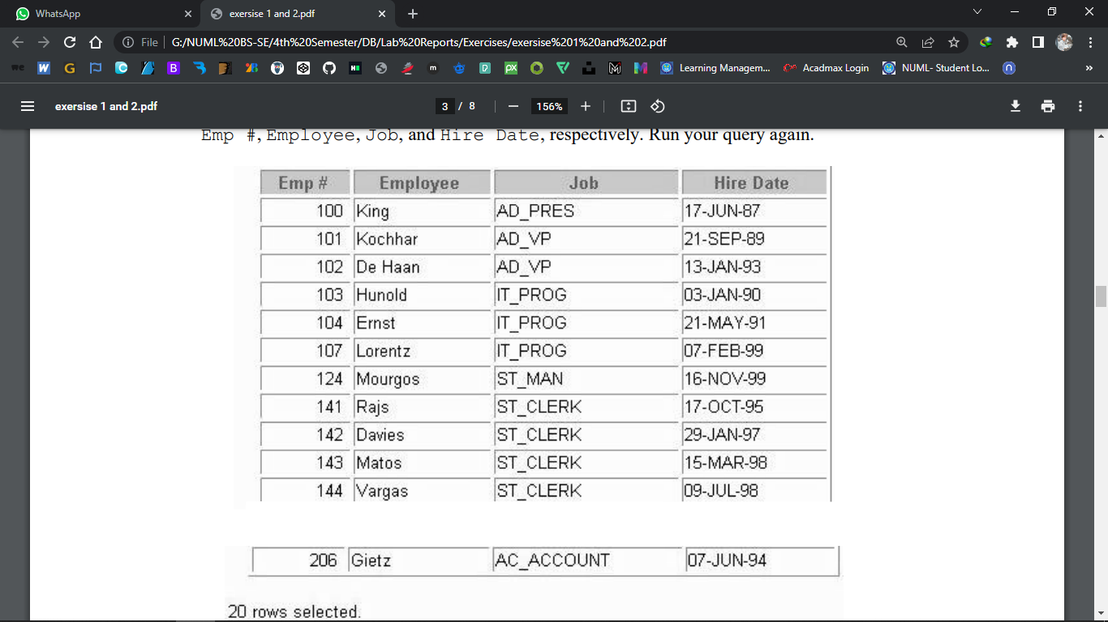

**Answer:**

**SELECT employee_id "Emp #", last_name "Employee",**

**job_id "Job", hire_date "Hire Date"**

**FROM employees**;

**Question # 11**

Display the last name concatenated with the job ID, separated by a comma and space, and name the column Employee and Title.

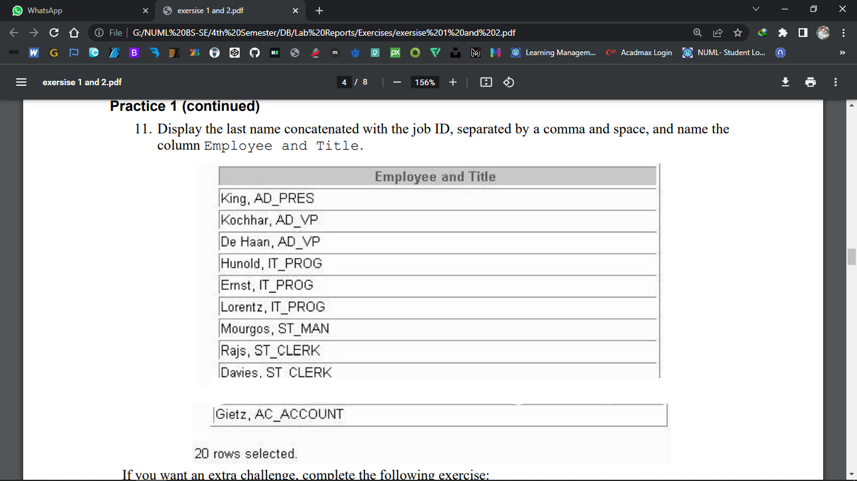

**Answer**

**SELECT last_name||', '||job_id "Employee and Title"**

**FROM employees;**

**Question # 12**

Create a query to display all the data from employees table. Separate each column by a comma, name the column THE_OUTPUT

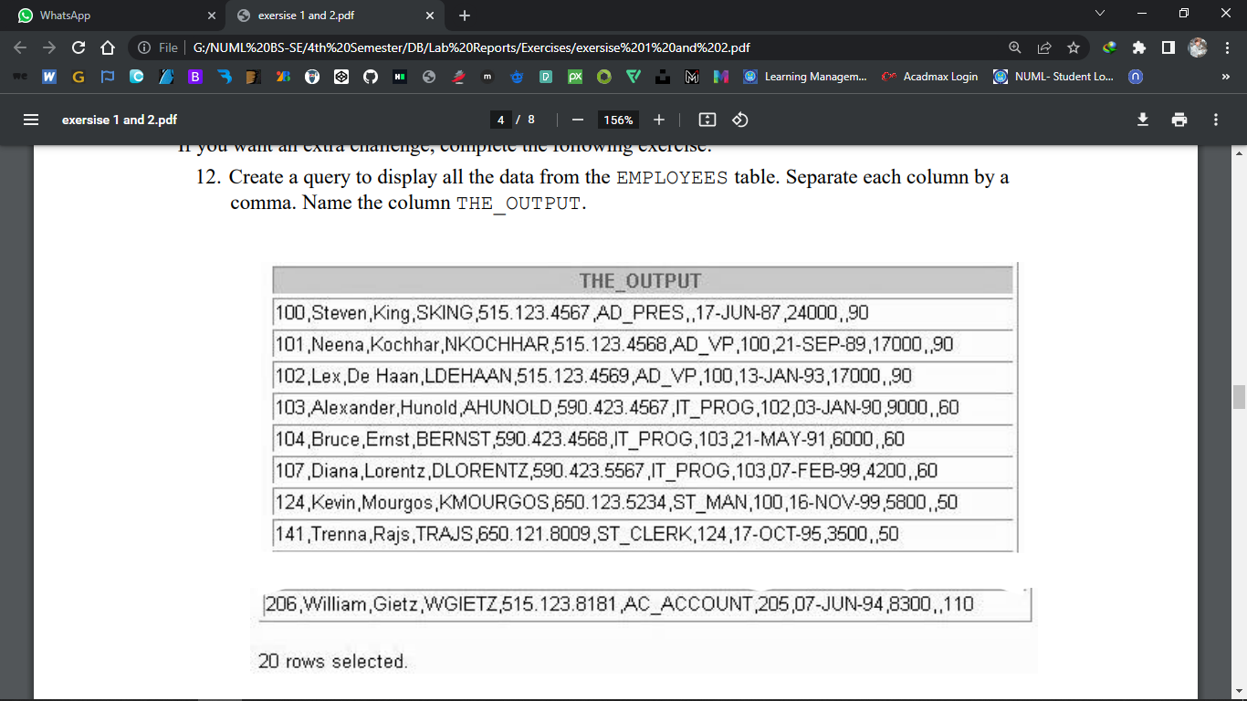

**Answer**

**SELECT employee_id || ',' || first_name || ',' || last_name || ',' || email || ',' || phone_number || ','|| job_ id || ',' || manager_id || ',' || hire_date || ',' || salary || ',' || commission_pct || ',' || department _id THE_OUTPUT FROM employees;**